 | American International University-Bangladesh (AIUB)  Department of Computer Science
 | Course Name: COMPUTER GRAPHICS |  | Course Code: CSE 4118
 | Faculty Name: DIPTA JUSTIN GOMES |  | Semester: FALL 2025-2026
 | Section: J  Student Name: NILOY PAUL |  | MID Term LAB Task-3  Student ID: 23-51773-2

DDA and Integer Pixel Grid
1. Construct a OpenGL Program containing the following conditions:
a. Use a separate init() function to declare your own co-ordinate system. Use the
range (-100, 100, -100, 100).
b. Construct a display function using DDA Algorithm to generate a straight line
with input: X1, Y1 (initial vertex) and Xn,Yn (Final Vertex). Consider all three
conditions of the DDA Algorithm while implementing the algorithm.
c. Create two lines as given below using DDA algorithm:
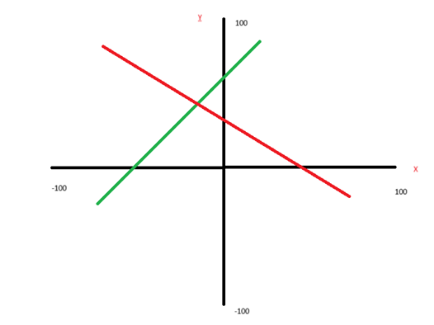

OpenGL Code

#include<windows.h>
#include<iostream>
#include<math.h>
#include <stdio.h>
#include<GL/gl.h>
#include <GL/glut.h>

using namespace std;

int X1, Y1, X2, Y2, X3, Y3, X4, Y4;

void MidPointslINE(int x0, int y0, int xn, int yn)
{
int dx = xn - x0;
int dy = yn - y0;
int x = x0, y = y0;

// Color: green if dy/dx >= 0, red otherwise
if ((float)dy / dx >= 0)
glColor3ub(0, 255, 0);
else
glColor3ub(255, 0, 0);

glBegin(GL_POINTS);

if (abs(dx) >= abs(dy))
{ // |m| <= 1 → drive along x
int d = 2*abs(dy) - abs(dx);
int dE = 2*abs(dy);
int dNE = 2*(abs(dy) - abs(dx));
int sx = (dx > 0) ? 1 : -1;
int sy = (dy > 0) ? 1 : -1;

while (x != xn)
{
glVertex2i(x, y);
if (d < 0)
d += dE;
else
{ d += dNE; y += sy; }
x += sx;
}
}
else
{ // |m| > 1 → drive along y
int d = 2*abs(dx) - abs(dy);
int dE = 2*abs(dx);
int dNE = 2*(abs(dx) - abs(dy));
int sx = (dx > 0) ? 1 : -1;
int sy = (dy > 0) ? 1 : -1;

while (y != yn)
{
glVertex2i(x, y);
if
(d < 0) d += dE;
else
{ d += dNE; x += sx; }
y += sy;
}
}

glVertex2i(xn, yn); // plot endpoint
glEnd();
glFlush();
}

void MidPoints()
{
glClear(GL_COLOR_BUFFER_BIT);
glColor3f(0,0,0);
glBegin(GL_LINES);
glVertex2i(-100,0); glVertex2i(100,0);
glVertex2i(0,-100); glVertex2i(0,100);
glEnd();

MidPointslINE(X1, Y1, X2, Y2);
MidPointslINE(X3, Y3, X4, Y4);
glFlush();
}

void myInit(void)
{
glClearColor(1.0, 1.0, 1.0, 0.0);
glPointSize(3.0);
glMatrixMode(GL_PROJECTION);
glLoadIdentity();
gluOrtho2D(-100, 100, -100, 100);
}

int main(int argc, char** argv)
{
glutInit(&argc, argv);
glutInitDisplayMode(GLUT_SINGLE | GLUT_RGB);
glutInitWindowSize(640, 480);
glutInitWindowPosition(150, 150);
glutCreateWindow("Midpoint Line Algorithm - CG Sec J");

cout << "Enter initial point for line 1 [X1 Y1]: "; cin >> X1 >> Y1;
cout << "Enter final point for line 1 [X2 Y2]: "; cin >> X2 >> Y2;
cout << "Enter initial point for line 2 [X3 Y3]: "; cin >> X3 >> Y3;
cout << "Enter final point for line 2 [X4 Y4]: "; cin >> X4 >> Y4;

myInit();
glutDisplayFunc(MidPoints);
glutMainLoop();
}

Output
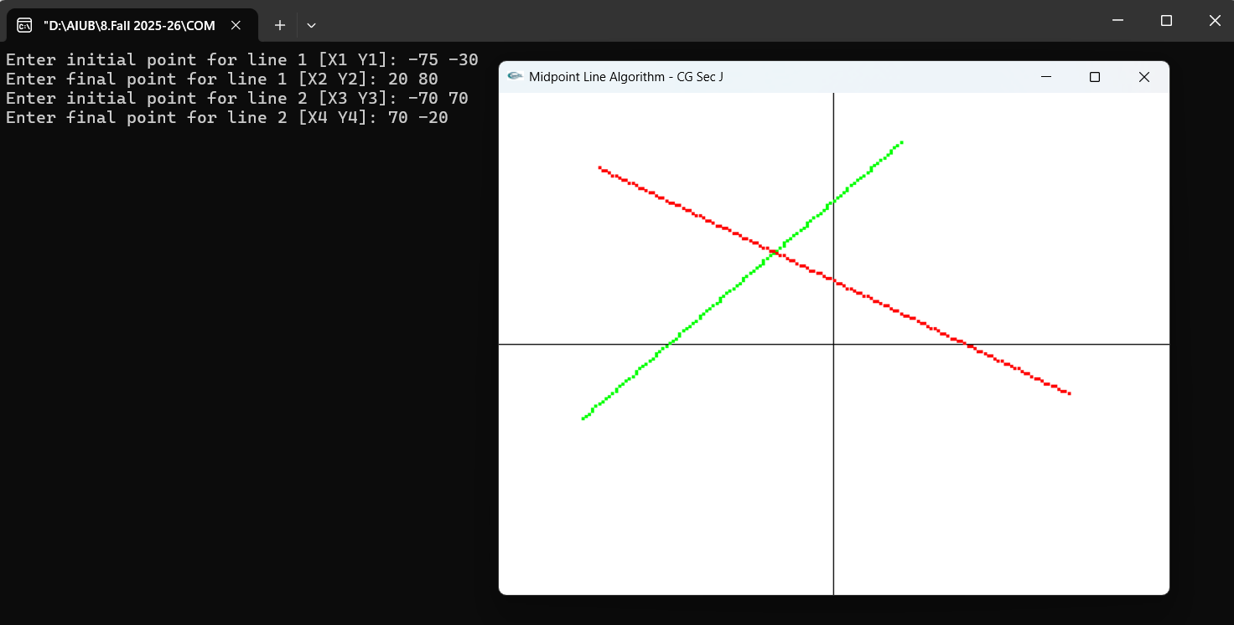

THE END

